**Challenge 1 Written Analysis**

The project is designed to understand how excel is powerful tool to organize and analyze data.

I was a little bit confused at the beginning and seek help from Jose. After Jose’s help, I realize that I need to go through the syllabus step by step. I downloaded the Kickstarter worksheet and walkthrough the practice after that everything cleared up and gotten simple.

This practice helps to analyze the data to see relationship between theater outcome and launch date, and outcome vs goals. Below is an example graph to see the relationship of theater outcome and launch date.

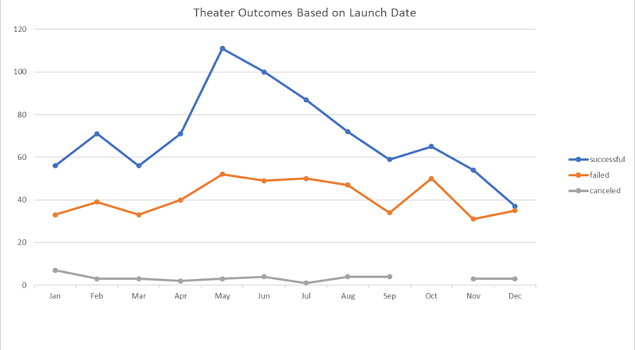

Based on the above analysis project success rate and number of projects is higher during the second quarter of the year and low during the last quarter, this shows that fund raising designed strategically to increase success rate during second and part of third quarter. Theater outcome is influenced by launch date.

On the other hand, outcome is inversely related to goals, as goals getting higher failure and cancelation increased and success decreased. Goals needs to be set at realistic level. 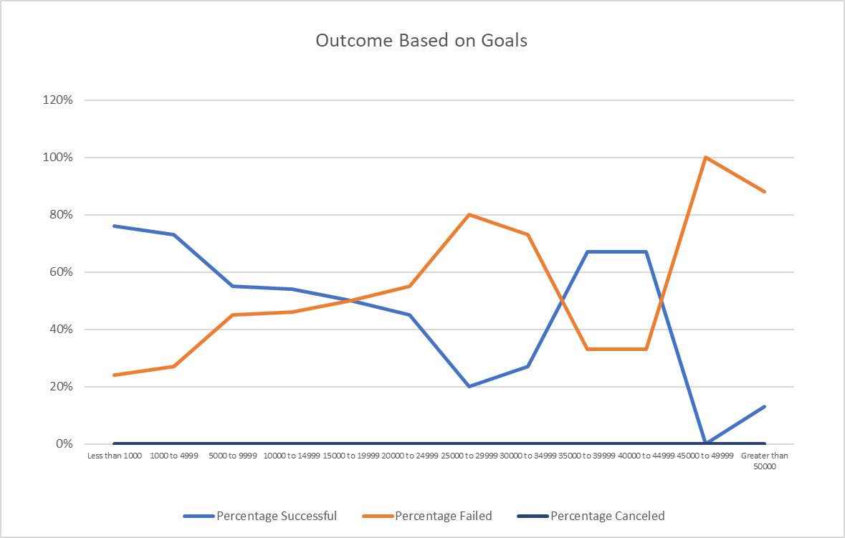

The data is limited to draw a more comprehensive conclusion to show relationship between project success and seasonal & yearly events (Like holly days and school summer breaks). Launch date is more general.